**GREEN VIEW PUBLIC SCHOOL**

**PERIODIC TEST 1**

**SESSION: 2021-2022**

**SUBJECT: SCIENCE**

**CLASS: V**

**MM: 20**

**DATE: TIME: 1 HOURS**

**General Instructions:**

1. ***All questions are compulsory.***
2. ***Marks for each question are indicated against it.***
3. ***Writing should be neat and clean***

* **The question paper has 6 questions and 2 pages**

**Q1. Multiple choice questions: (1 x 5 = 5)**

1. **_______________ are very strong elastic bands of tissues.**
2. **Muscles b) Joints**

**c) Nerves d) Tendons**

1. **___________ Joint allows us to bend our head up, down, and sideways.**
2. **Hinge b) Ball and socket**

**c) Pivot d) Sliding**

1. **The reflex action is controlled by**
2. **Cerebrum b) Cerebellum**

**c) Medulla d) Spinal cord**

1. **_________ is at the back of the eye, where the images are formed**
2. **Retina b) Pupil**

**c) Iris d) Cornea**

1. **Which of the following sources are renewable sources of energy**
2. **Sola energy b) Wind energy**

**c) Geothermal energy d) All of these**

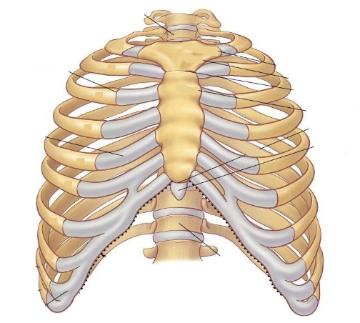**Q2. Identify the diagram shown and answer the given question: (2)**

1. **Name ___________________**
2. **It protects _________________**
3. **Number of bones_____________**
4. **Shape of the bones ____________**

**Q3. Answer the following questions (1 x 6 = 6)**

1. **Name different parts of a seed.**
2. **Define the term germination.**
3. **Name the essential components of food.**
4. **Explain the importance of balanced diet.**
5. **What is first-aid?**
6. **What should we do if our clothes catch fire?**

**Q4. Answer the following questions (2 x 2 = 4)**

1. **What are deficiency disease? Name any 2 deficiency diseases and give reasons for their occurrence.**
2. **How are animals helpful in the dispersion of seeds?**